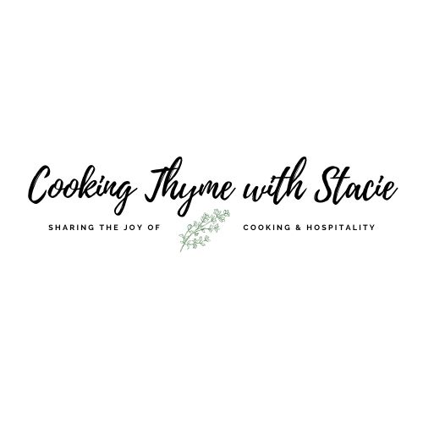

Tea with Ann and Friends
Saturday, April 30, 2022
1 – 2:30 pm EST

Menu
Chocolate Chip Scones
Tea Sandwiches: Goat Cheese and Roasted Red Pepper &
Chicken and Orange
Chocolate Mousse

To access the class video copy and paste the link into your browser:

www.cookingthymewithstacie.com/private-class-videos/twann

www.cookingthymewithstacie.com

Shopping List

Before shopping, I recommend you look through the recipes and decide how much you would like to prepare during the class. The recipes can easily be halved so you do not end up with too much food if you are not planning to serve this to a group.
**All quantities in the following list are for the FULL recipe!

Dairy
- 3 3/4 cups heavy whipping cream
- 2 TB unsalted butter, melted
- 12 ounces or 1.5 packages cream cheese, softened
- 1 to 2 TB mayonnaise
- 8 ounces softened goat cheese
Pantry
- 2 cups all-purpose flour
- 1 TB baking powder
- ¼ cup sugar, plus 2 -3 TB sugar
- ¾ cup chocolate chips
- ½ cup plus 4 TB chopped pecans or walnuts, toasted
- 2 roasted red peppers (I normally use jarred, but you can roast fresh ones if desired)
- 12 ounces semi-sweet chocolate chips
- 1 TSP vanilla

Produce
- Fresh raspberries to garnish chocolate mousse if desired

Protein
- 1 ½ cups chopped cooked chicken breast (I recommend shredding rotisserie chicken)

Specialty
- 12 raisin bread slices
- ½ cup mandarin orange segments
- 10 thinly sliced pieces of bread (I prefer Pepperidge Farm brand)
- 1 TB Rum (optional)

Spices
- Salt
- Pepper
**At the end of the packet I have some suggestions for tea blending. I recommend brewing tea to go with our menu such as Earl Grey or your favorite herbal blend.

Here is the bread I buy for the tea sandwiches:
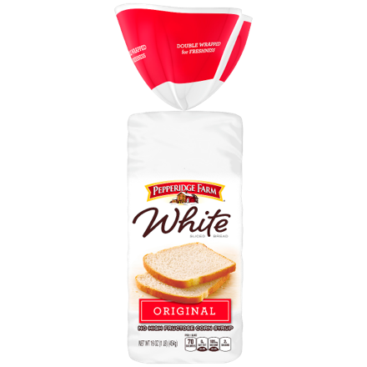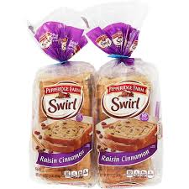

Equipment Needed

Bakeware
- 2 Large rimmed baking sheets
- Parchment paper or Silpat mat
Electric
- Hand-held mixer
Utensils
- Chef’s knife
- Cutting board
- Measuring cups and spoons
- Mixing bowls, various sizes
- Pastry brush

Mis en Place
The French culinary term for “everything in its place”

In order to have a smooth cooking experience, I recommend that you retrieve all the equipment you will need for the class before we begin. In addition, if you have time, group your ingredients by recipe. Most chefs place their components on sheet pans – this is ideal if you have the room.

Measuring things in advance is optional, but I find if I measure things in advance I am less likely to get lost… such as “did I put in the baking powder?”

- Bring cream cheese to room temperature
- Bring goat cheese to room temperature

Chocolate Chip Scones

Makes 12 scones

2 cups all-purpose flour
1 TB baking powder
½ tsp salt
¼ cup granulated sugar, plus 2 -3 TB sugar
¾ cup chocolate chips
1 ¼ cups heavy whipping cream
2 TB unsalted butter, melted

Preheat oven to 425˚.

Place flour, baking powder, salt, ¼ cup sugar in a large bowl and whisk them together. Add chocolate chips and stir gently. Pour in heavy cream and mix together with a fork until sticky. On a floured surface, knead dough 10 times.

Place dough on a parchment lined cookie sheet and pat into a 9” disk. Brush with melted butter and sprinkle with sugar. Cut into 12 pie shaped wedges and bake 15 – 17 minutes.

Chicken and Orange Tea Sandwiches

- 12 raisin bread slices
- 1 (8-ounce) package cream cheese, softened
- 1 ½ cups chopped cooked chicken breast
- ½ cup chopped pecans or walnuts, toasted
- 1 to 2 TB mayonnaise
- ¼ teaspoon dried thyme
- ¼ tsp salt
- ¼ tsp pepper
- ½ cup mandarin orange segments

- Cut crusts from bread slices. Cut bread slices into 4 triangles, and place on baking sheet.

- Bake at 400° for 5 minutes or until toasted.

Combine cream cheese and next 6 ingredients in a large bowl until blended. Cover and chill until ready to serve. Spoon 1 tablespoon of cream cheese mixture onto 1 side of each raisin bread triangle; top each with a mandarin orange segment.

Roasted Red Pepper and Goat Cheese

Makes 20

8 ounces softened goat cheese
4 ounces softened cream cheese
2 roasted red peppers, sliced
10 thinly sliced pieces of bread
4 TB finely chopped pecans

In a medium size mixing bowl, beat together the goat and cream cheeses with a hand-held mixer. Spread mixture onto 5 slices of bread top with slices of roasted red pepper. Top each sandwich with another slice of bread. Remove crusts and cut into 4 triangles. On one cut side, spread some remaining cheese mixture and dip in the chopped pecans.

Make Ahead Directions
I prefer to make tea sandwiches the same day I plan to serve them.
If you have to make them ahead:
Leave the crusts on! Place them in airtight containers with a piece of parchment paper between the layers with a slightly damp paper towel over the top layer. Place them in the refrigerator overnight. Remove and cut off the crusts. Place a dampened paper towel over the sandwiches until ready to serve so the bread does not dry out.

Easy Chocolate Mousse

Makes 6 large servings or 12 small servings
*Can easily be halved if desired

2 ½ cups heavy whipping cream, divided
12 ounces semi-sweet chocolate chips
1 TSP vanilla
1 TB Rum (optional)

Place chocolate chips and ½ cup whipping cream in microwave safe bowl. Microwave on high 45 seconds then stir. Microwave an additional 45 seconds. Some of the chocolate may not look all the way melted – just continue to stir it and it will melt completely. (You do not want to burn the chocolate and have to start all over!)
When all the chocolate is melted, stir in vanilla and rum. Cool mixture slightly.

In a separate bowl, using a hand mixer - beat the remaining 2 cups of heavy whipping cream until soft peaks form, and then fold into chocolate mixture. At this point you can cover and chill the mixture or spoon into individual serving dishes. Chill 2 hours before serving.

I suggest garnishing with additional whipped cream and/or fresh raspberries.

If you desire to make your own tea mix, here are some guidelines:

Tea Blending
Blending tea is an art not a science. The final result depends really on your personal taste. Here are a few guidelines.
1.) Decide on a base tea – Black, Green, Red (rooibos), or White
2.) The final mixture should contain about 2/3 tea leaves and the remainder is the flavoring including, herbs, dried fruits or dried flowers.
3.) Blends will be easier if you select items of similar size.
Types of Black Tea
Black, Oolong, Earl Grey, English Breakfast, Ceylon, Darjeeling
Types of Green and White Tea
Green, Sencha Green, Young Hyson, Gunpowder, Jasmine, Yerba Mate, White
Types of Red Tea
Rooibos – it is technically not a tea. It is a South African evergreen shrub. The leaves are harvested and dried and seeped with water to make an herbal tea.

The tea filters I use are made by Bstean and you can purchase them at Amazon. Here is the link
Tea Filters

