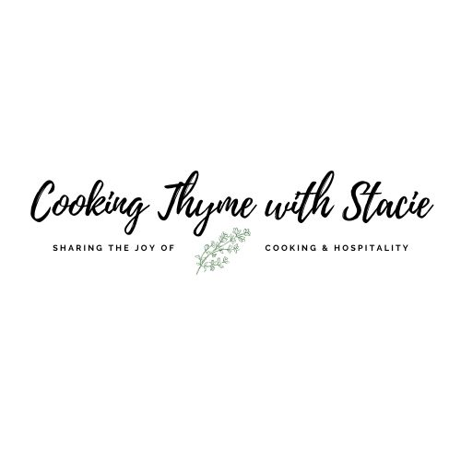

Private Live Stream Cooking Class for NCMEC

Dinner Menu
Thursday, June 17, 2021
5 - 6 pm EST

www.cookingthymewithstacie.com

Zoom Link:
https://us02web.zoom.us/j/89020897271

Shopping List

Dairy/Freezer
- 1 cup frozen peas
- ½ cup Feta, buy the block, not crumbles

Pantry
- ½ cup olive oil
- 1 TSP Dijon mustard
- 2 TB pine nuts, toasted (you can substitute walnuts or pecans if preferred)
- 1 cup chicken broth (I use Better than Bouillon brand)
- 1 TB balsamic vinegar
- Cooking spray

Produce
- 1 bag (5 ounces) baby spinach
- 1 package (8 ounces) sugar snap peas
- 1 lemon
- 1 yellow pepper
- 1 red pepper
- 1 large shallot
- 1 ½ tsp chopped fresh rosemary

Protein
- 4 (6-ounce) breasts of chicken, skinless, boneless

Spices
- kosher salt
- black pepper
- 3/4 tsp fennel seeds, crushed
- ¼ tsp garlic powder
- ¼ tsp dried oregano

Equipment

Baking
- 11” x 7” baking dish (you may substitute a 9” x 13”)

Pots and Pans
- Large skillet

Tools/Utensils
- Chef’s knife
- Cutting board
- Measuring cups and spoons
- Mixing bowls
- Mortar and pestle or Ziploc bag
- Pastry brush
- Whisk
- Wooden spoon

Specialty
- Plastic wrap

Mise en Place
The French culinary term for “everything in its place”
In order to have a smooth cooking experience, I recommend that you retrieve all the equipment you will need for the class before we begin. In addition, if you have time, group your ingredients by recipe. Most chefs place their components on sheet pans – this is ideal if you have the room.
- I recommend you read through the recipes before class.
- Collect all the ingredients and organize them by recipe
- I encourage you to prep your ingredients so that you will have more time to watch the instruction.
I will be cutting and chopping all the ingredients with you, but you may want to do this in advance if you think you will need some extra time during class.

Warm Pea and Spinach Salad with Feta Cheese

Serves 4

1 bag (5 ounces) baby spinach
1 package (8 ounces) sugar snap peas
1 cup frozen peas
¼ cup plus 1 TB olive oil
Juice from 1 lemon
1 TSP lemon zest
1 TSP Dijon mustard
Kosher salt and pepper
2 TB pine nuts, toasted
½ cup Feta, broken into large chunks

In a large skillet heat 1 TB olive oil over low heat, add the sugar snap peas and toss to coat. Cook 2 minutes, stirring occasionally. Add the frozen peas and continue to cook until warmed through.

In a small bowl, whisk together the juice from 1 lemon, the lemon zest, the mustard and a pinch of salt and pepper. While whisking, drizzle in the ¼ cup olive oil.

Toss the spinach, cooked vegetables and some of the dressing in a large bowl. Add dressing to your taste, you may not need it all. Divide among 4 plates. Top with feta cheese chunks and pine nuts.

Roast Chicken with Balsamic Bell Peppers

Makes 4 generous servings

Ingredients for chicken:

1/2 tsp salt
3/4 tsp fennel seeds, crushed
¼ tsp black pepper
¼ tsp garlic powder
¼ tsp dried oregano
4 (6 ounce) breasts of chicken, skinless, boneless
3 TB olive oil, divided
Cooking Spray

Preheat the oven to 450˚ F.

Lightly grease 11” x 7” baking dish with cooking spray.

Place each chicken breast between two sheets of plastic wrap and slightly pound them until they are an even thickness.

In order to crush the fennel seeds, use a mortar and pestle or place the seeds in a Ziploc bag and crush them with a heavy bottom pot or rolling pin.

Combine salt, fennel seeds, black pepper, garlic powder and dried oregano in a small bowl. Using a pastry brush, cover each chicken breast with 1 ½ TSP olive oil and sprinkle spice mixture all over the chicken breasts.

Add 2 TB olive oil to a large skillet. Heat the skillet over medium-high heat. Add chicken skin-side down, cook 3 minutes or until browned, then turn chicken over and cook 2 additional minutes. (Note: chicken will not be cooked through!)
Arrange chicken in a lightly greased dish and bake for 10 minutes (slightly longer if using thick pieces of chicken.)

Ingredients for Bell Pepper Topping:

1 yellow pepper thinly sliced
1 red pepper thinly sliced
½ cup thinly sliced shallots (about 1 large)
1 ½ tsp chopped fresh rosemary
1 cup chicken broth
¼ tsp salt
¼ tsp pepper
1 TB balsamic vinegar

In the same pan you browned the chicken, add an additional 1 TB olive oil and turn the burner to medium-high heat. Add the bell peppers, shallots, and rosemary; sauté 3 - 4 minutes.

Stir in broth, using a wooden spoon, scrape up the brown bits from the bottom of the pan.

Reduce the heat and simmer 5 minutes. Then increase heat to medium-high. Stir in vinegar, salt, pepper, cook 3 minutes stirring frequently.
Serve mixture over chicken.

