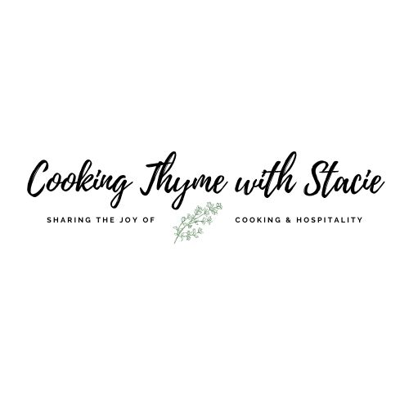

Holiday Foodie Gifts
Thursday, December 8, 2022
5 – 6:30 pm EST

- Menu -
Homemade Vanilla
Caramel Popcorn
Chocolate Almond and Cranberry Clusters
Homemade Granola

To access the class video click on the link below

www.cookingthymewithstacie.com/video-class-purchase/holiday22fg

www.cookingthymewithstacie.com

Shopping List

Specialty
- 8 ounces vodka
- 4 Vanilla beans – link below to order these!
- Glass jar

Dairy
- 8 TB unsalted butter (1 stick)

Pantry
- 1/4 cup vegetable oil
- 2/3 cup popcorn kernels
- 1 cup dark brown sugar
- ¾ cup corn syrup
- 1 TSP baking soda
- 1 cup whole almonds
- 1/3 cup dried cranberries (Craisins)
- 4-ounces bittersweet chocolate (you may substitute semi-sweet if you prefer)
- 4 cups old-fashioned rolled oats
- ½ cup melted coconut oil
- ½ cup honey
- ¾ cup slivered almonds (or nut of your choice such as chopped walnuts or pecans)
- ½ cup sweetened flaked coconut
- 1 TSP vanilla

Spices
- 1 TSP coarse sea salt
- 1 TSP cinnamon
- ¾ TSP Kosher salt

Equipment List
Baking
- Parchment paper
- Rimmed baking sheets
Pots and Pans
- Dutch oven with tight fitting lid
- Large saucepan
- Large skillet
Utensils
- Chef’s knife
- Cutting board
- Funnel
- Mixing bowls
- Measuring cups and spoons
- Spatula

Mis en Place
The French culinary term for “everything in its place”
In order to have a smooth cooking experience, I recommend that you retrieve all the equipment you will need for the class before we begin. In addition, if you have time, group your ingredients by recipe. Most chefs place their components on sheet pans – this is ideal if you have the room.
- If you want to be a little ahead, go ahead and pop the corn before class!
- Make sure you have a clean glass jar for the vanilla
- I have suggestions on each recipe for packaging each item – these are NOT on the shopping list.
Homemade Vanilla

4 vanilla beans, Grade B
8 ounces vodka*, 80 proof, 40 % alcohol
1 glass jar

Take a knife a cut each vanilla bean open exposing the seeds, place in a clean glass jar. If they are too long you can cut them in half. Using a funnel, pour in the vodka, making sure to completely cover the beans. Seal. Shake the bottle every few days and keep in a cool dark place.

You can keep using the same beans as long as you keep them covered by adding alcohol to the top and shaking upon each addition.

For gifting: if you plan to give it as a gift, either
a.) remove the beans so the recipient does not have to keep filling up the bottle
b.) leave the beans in the jar with some instructions for use attached.

6 months is the optimal amount of time to leave the beans, but 2 months is satisfactory.

*To be sure your vanilla is gluten free, purchase a non-flavored vodka.
** There is no appreciable taste difference if you use more expensive grade A vanilla beans, grade B is fine!

These are the bottles I use:

Glass Bottles

These are the vanilla beans I buy in packages of 25, they also sell them in smaller sizes, too.

Vanilla Beans

A 1liter bottle of vodka will make approximately 4, 8-ounce bottles

Vanilla Instructions for gifting:

When giving this as a gift, a label makes the vanilla extract look really professional and pretty. You could remove the vanilla beans before gifting and reuse them by adding them to new jars and filling with vodka and repeating the process. Or tell the recipient that they can continue to top off the vanilla with vodka each time they use it to make it last quite a bit longer.

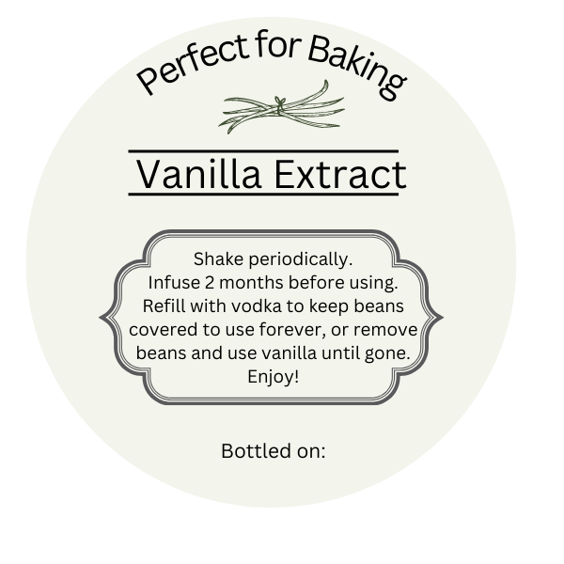
You can copy print this on a round Avery label and affix to each jar.
Go to Avery.com for label printing instructions

Caramel Popcorn
1/4 cup vegetable oil
2/3 cup popcorn kernels
8 TB unsalted butter (1 stick)
3⁄4 cup dark brown sugar
3⁄4 cup corn syrup
1 TSP coarse sea salt
1 TSP baking soda
Cooking Spray
In a large Dutch oven, pour in the vegetable oil and then the kernels of popcorn. Cover the pot with a tight-fitting lid and place on the stove over medium heat. Occasionally shake the pot and remove from heat when there is more than a second or two between pops and most of the popcorn has popped.
Preheat oven to 250 ̊.
In a large saucepan, melt the stick of butter over medium-low heat. Next stir in the brown sugar, corn syrup and sea salt, combine until well mixed. Bring the mixture up to a boil. Let it gently boil for 2 minutes. (You may have to turn down the heat a bit, so it does not boil over.) Add 1 teaspoon baking soda and stir. The mixture will be very foamy! Pour it over the popped corn. Divide the popcorn between two well-greased, rimmed baking sheets.
Place in the oven for 20 minutes, then stir to coat the popcorn with caramel. After about 40 minutes remove the pans from the oven and spread the popcorn on parchment paper on the counter. Let cool completely. Break apart and store in an airtight container up to one week.
I place the caramel popcorn in these clear bags for gifting:

Popcorn Bags
Chocolate Almond Clusters

Makes about 16, 2” clusters

1 cup whole almonds
1/3 cup dried cranberries
4 ounces bittersweet chocolate
Sprinkle of sea salt

Line a large rimmed baking sheet with parchment paper.

Chop the chocolate and place in a microwave safe bowl. Microwave on high 30 seconds, stir. Repeat another 30 seconds. Stir until fully melted. Toss in the almonds and cranberries, stir to coat well. Drop tablespoon size mounds onto the baking sheet. Sprinkle with coarse sea salt. Chill 15 minutes.

I place 3-4 clusters in these clear boxes I purchased from Amazon for gifting:
Clear Box 4" x 4"

Homemade Granola

4 cups old-fashioned rolled oats
1 TSP cinnamon
½ cup melted coconut oil
½ cup honey
¾ cup slivered almonds (or nut of your choice)
½ cup sweetened flaked coconut
¼ cup packed dark brown sugar
1 TSP vanilla
¾ TSP Kosher salt

Preheat the oven to 350˚.

Place all the ingredients in a large bowl and mix well. Pour out onto a Silpat lined baking sheet or line sheet with parchment paper. Cook about 20 minutes, stirring about half way through cooking.
Remove the baking sheet from the oven and let cool completely. The granola will crisp up as it cools. Store in an airtight container for up to 2 weeks.

**After it has cooled you may add dried fruit pieces and/or chocolate chips.

I gift this in mason jars like these:
Glass jars

