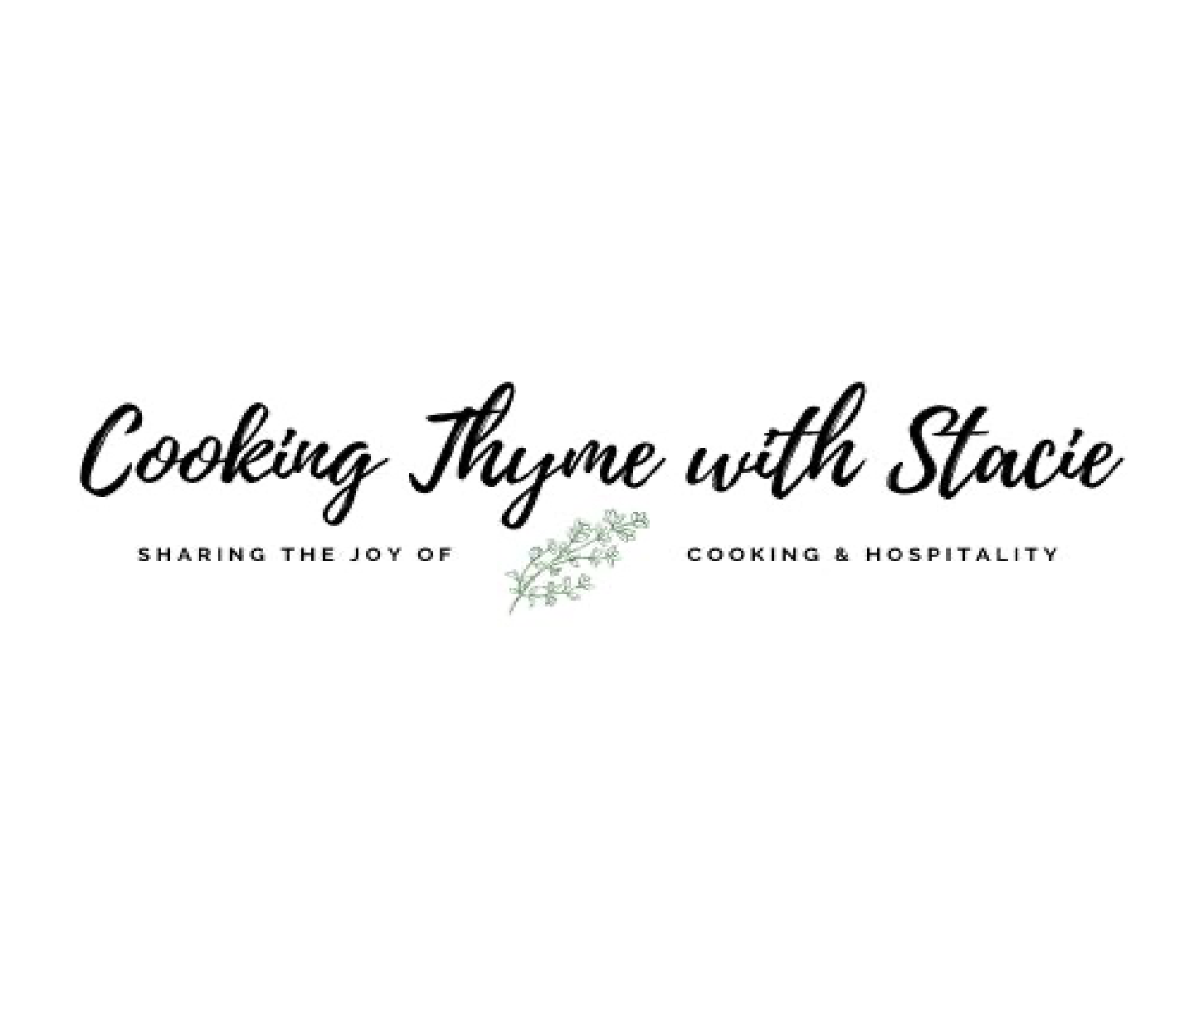

Fall 2022 Dinner Party

Menu
Roasted Cauliflower Soup
Pecan Encrusted Salmon Filets with Creamy Mustard Sauce
Goat Cheese Mashed Potatoes

To access the class video, copy and paste the following link into your browser:

www.cookingthymewithstacie.com/video-class-purchase/wqd22

www.cookingthymewithstacie.com

Shopping List
Dairy
- 1 cup heavy whipping cream
- 6 TB butter
- 1 ½ cups sour cream
- ½ cup milk
- 8 ounces goat cheese (I buy this at Trader Joe’s)
Pantry
- 3 TB olive oil
- 5 cups Better than Bouillon vegetable broth
- 5 TB Dijon mustard
- ¼ cup seasoned Panko crumbs
- ¾ cup finely chopped pecans
- ¼ cup chicken broth
Produce
- 2 heads of cauliflower, florets only
- 1 cup yellow onion, diced
- 5 sprigs fresh thyme
- 2 whole heads of garlic
- 3 pounds Yukon gold potatoes
Protein
- 1 side of salmon (about 2 ¼ lbs.)
Spices
- Salt and pepper
- 1 bay leaf

Specialty
- ½ cup white wine

Equipment Needed

Baking
- 2 - 3 rimmed baking sheets
Electric
- Immersion blender

Pots and Pans
- Large Dutch oven
- Small saucepan

Utensils
- Chef’s knife
- Cutting board
- Measuring cups and spoons
- Mixing bowls
- Parchment paper
- Potato Masher
- Vegetable peeler
- Whisk

Mis en Place
The French culinary term for “everything in its place”

In order to have a smooth cooking experience, I recommend that you retrieve all the equipment you will need for the class before we begin. In addition, if you have time, group your ingredients by recipe. Most chefs place their components on sheet pans – this is ideal if you have the room.
- Cut up cauliflower florets
- Make the broth
- Clean salmon of any pin bones
- Preheat oven to 425˚

Roasted Cauliflower Soup

6 – 8 Servings

3 TB olive oil, divided
2 heads of cauliflower, florets only
1 cup yellow onion, diced
5 cups Better than Bouillon vegetable broth
5 sprigs fresh thyme
1 bay leaf
¾ cup heavy whipping cream
Head of roasted garlic (see additional recipe)

Preheat oven to 425˚.

Place the cauliflower on baking sheets in a single layer. Toss with 2 TB of olive oil. Season the vegetables with salt and pepper. Roast for 30 minutes, turning once. Once the cauliflower is finished cooking, set aside a few florets for a garnish to top the soup.

In a large Dutch oven, heat one additional tablespoon of olive oil, add the diced onion and cook over medium - low heat about 8 minutes or until translucent. Stir in the vegetable broth, thyme and bay leaf. Bring the mixture up to a boil.

Reduce heat and add the roasted cauliflower and roasted garlic to the broth. Cook about 10 minutes over medium – low heat until the vegetables are very soft.

Use an immersion blender to purée the soup until it is very smooth. Add the whipping cream and salt and pepper to taste. Heat through.

Garnish with fresh thyme and cauliflower florets.

Roasted Garlic

1 head of garlic
1 ½ TB olive oil

Preheat oven to 425˚. Remove outer skin layers of garlic bulb, leaving each individual skin of the cloves intact. Using a sharp knife, cut off the top of the bulb, exposing the cloves. Place the bulb on a small sheet of aluminum foil and drizzle with olive oil. Cover completely with the foil making a folded packet and place on a baking sheet. Bake for 30 minutes. Remove and let cool slightly. Once they are cooled you can squeeze out the garlic cloves.

Pecan Encrusted Salmon Filet

Serves 5 – 6

- side of salmon (about 2 ¼ lbs.) **
Salt and pepper
- TB Dijon mustard
¼ cup seasoned Panko crumbs
¾ cup finely chopped pecans

Preheat oven to 425˚.

In a small bowl combine the nuts and Panko crumbs. Set aside.

Check the salmon for any pin bones. Line a large rimmed baking sheet with parchment paper. Lay the salmon skin side down. Generously season the fish with salt and pepper.

Spread an even coat of Dijon mustard over the salmon. Gently press an even layer of the nuts/crumb mixture over the mustard.

Place the salmon in the oven, bake 18 - 20 minutes or until the fish registers 145˚ in the thickest portion of the fish.

**Please note, if you chose to bake individual portions (4 -6 ounces each, reduce the baking time to 10 – 12 min)

Creamy Mustard Sauce

2 TB butter
- cloves garlic, minced
½ cup white wine
- TB Dijon mustard
¼ cup heavy whipping cream
¼ cup chicken broth
Salt and pepper to taste

Melt the butter in a skillet over medium-low heat, add the garlic and cook 30 seconds. Pour in the white wine and cook until reduced by half. Then add the mustard and stir until well incorporated. Next add ¼ heavy whipping cream and ¼ cup chicken broth. Cook until bubbly. Salt and pepper to taste. Serve warm.

Goat Cheese Mashed Potatoes

Serves 8

3 pounds Yukon gold potatoes, peeled and cut into large, evenly sized chunks
5 garlic cloves, whole
8 ounces goat cheese, room temperature
4 TB unsalted butter, at room temperature
- ½ cups sour cream
½ cup milk
- TSP Kosher salt
½ TSP black pepper, freshly ground

In a large pot add the Yukon gold potatoes, whole garlic cloves, and about 1 TB of kosher salt to make the water salty “like the sea”, and water to cover. Bring the pot to a boil, reduce the heat and simmer for 20 minutes, or until the potatoes are easily pierced with a fork.

Drain the water from the potatoes, mash the potatoes and garlic together until smooth. While the potatoes are still hot, stir in the goat cheese, butter, sour cream, milk, salt and pepper.

