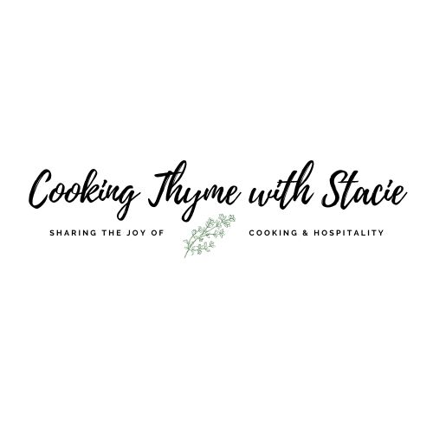

NOVA CC Cooking Class
Holiday Appetizers

Tuesday, November 25, 2025
5:30 – 6:30 pm EST

Menu
Spiced Butternut Squash Soup Shooters
Individual Tomato and Ricotta Tarts
Pears and Pancetta Rounds with Goat Cheese
Chocolate Mousse

Zoom Invitation
https://vccs.zoom.us/j/83157755341?pwd=tfapckMuF9PruUtirzLLUjxnh3l6Rj.1
Meeting ID: 831 5775 5341
Passcode: 335601

Shopping List
Dairy/Frozen
- 3 cups heavy cream
- 1/2 (4-oz.) package goat cheese
- 1 sheet of puff pastry
- Ricotta cheese, small container
- ½ cup Parmesan cheese

Pantry
- 2 TB olive oil
- 2 ½ cups low sodium chicken broth (or substitute with vegetable broth for vegetarian version)
- Honey for garnish
- Pesto, small jar
- 12 ounces semi-sweet chocolate chips
- 1 TSP vanilla
- Non-stick spray

Produce
- 1 pound butternut squash
- 1 firm ripe Anjou pear, peeled and quartered
- 2 large shallots
- 2 garlic cloves
- 2 Bartlett pears
- Fresh thyme for garnish
- ¾ cup cherry tomatoes
- Fresh basil, for garnish
- Raspberries for garnish

Protein
- 12 thin slices pancetta

Spices
- Salt
- Pepper
- 1/8 tsp ground ginger
- ½ tsp garam masala or curry powder

Specialty

- 2 TB dry white wine

- 1 TB rum (optional)

Equipment Needed
Baking
- 2, Large rimmed baking sheet
- Parchment paper
- Aluminum foil
- Rolling pin
- 2 ½” round biscuit cutter (or use a glass)
- Muffin tin

Electric
- Blender
- Hand mixer

Pots and Pans

Utensils
- Chef’s knife
- Cutting board
- Measuring spoons
- Measuring cups
- Spatula
- Mixing bowls

Mis en Place
The French culinary term for “everything in its place”
In order to have a smooth cooking experience, I recommend that you retrieve all the equipment you will need for the class before we begin. In addition, if you have time, group your ingredients by recipe. Most chefs place their components on sheet pans – this is ideal if you have the room.
- Preheat oven to 400˚
- Defrost Puff Pastry
- Arrange ingredients by recipe
- Save some time and make your vegetable/chicken broth

Spiced Butternut Squash and Pear Shooters

Makes 3 portions or 12 – 14 shooters

1 pound butternut squash, peeled, seeded and cubed (20 oz package from Trader Joe’s)
1 firm ripe Anjou pear, peeled and quartered
2 large shallots, peeled and halved
2 TB olive oil
½ tsp sea salt
¼ tsp freshly ground pepper
2 garlic cloves, minced
1/8 tsp ground ginger
½ tsp garam masala or curry powder
2 TB dry white wine
2 ½ cups low sodium chicken or vegetable broth
1 TB heavy cream

Preheat oven to 400˚F. Gently toss first 3 ingredients with oil; season with sea salt and pepper, and place in a rimmed baking pan. Bake 35 minutes or until tender and browned. Add garlic, ginger, and garam masala and toss well. Bake 5 more minutes.

Pour wine over the squash mixture and stir to deglaze the pan. Let stand 10 minutes. Transfer to a blender, add broth and puree until smooth. (For smoothest texture, press squash puree through a wire-mesh strainer, discarding solids.)

Transfer puree to a large saucepan, and stir in cream. Cook over medium heat 3 – 5 minutes or until heated through. Season with salt and pepper to taste. Ladle into small glasses.

** Garam Masala is a ground spice blend from Indian, Pakistan and South Asian cuisines. It is primarily made of: cumin, coriander, cardamom, cinnamon, pepper, cloves and nutmeg.

Adapted from myrecipes.com

www.cookingthymewithstacie.com

- Pancetta and Pears Appetizers

- 12 thin slices pancetta (about 1/3 lb.)
- 2 Bartlett pears
- 1/2 (4-oz.) package goat cheese, crumbled
- Freshly cracked pepper
- Honey
- Garnish: fresh thyme sprigs

Arrange pancetta slices in a single layer on an aluminum foil-lined baking sheet.
Bake at 450° 6 - 8 minutes or until golden. Transfer to a paper towel-lined wire rack using a spatula. Let stand 10 minutes or until crisp.
Cut pear crosswise into 6 thin rings. Core pear with an apple corer or remove center with small paring knife. Arrange on a serving platter. Top evenly with pancetta and goat cheese; sprinkle with pepper. Drizzle with honey just before serving. Garnish, if desired.

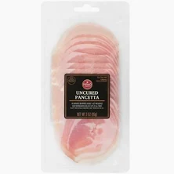 This is what you should look for in the deli section

To make these in advance, immediately soak pears after slicing in a salt bath for 5 minutes (1/2 TSP salt to 1 cup water) Then rinse and pat dry.

Individual Tomato Tarts

MAKES 12 APPETIZERS

1 sheet of puff pastry. thawed
¾ cup cherry tomatoes, halved
Pesto
Ricotta Cheese
½ cup Parmesan cheese, shredded
Fresh Basil, chopped

Unroll the puff pastry, and slightly roll out on floured surface. Using a 2 ½” cutter, cut out 12 circles.

Spray a muffin tin with non-stick spray. Place one pastry round in each muffin cup, pressing lightly around the edges. Place ½ TSP pesto in the bottom of each cup, top with ½ TSP ricotta cheese. Place 3 half tomatoes on the top of each cup. Sprinkle each cup with Parmesan cheese and a few pieces of basil.

Bake in a 400˚ oven for 13 – 15 minutes. Remove and eat warm or at room temperature.

Easy Chocolate Mousse

Makes 6 large servings or 12 small servings

2 ½ cups heavy whipping cream, divided
12 ounces semi-sweet chocolate chips
1 TSP vanilla
1 TB Rum (optional)

Place chocolate chips and ½ cup whipping cream in microwave safe bowl. Microwave on high 45 seconds then stir. Microwave an additional 45 seconds. Some of the chocolate may not look all the way melted – just continue to stir it and it will melt completely. (You do not want to burn the chocolate and have to start all over!)
When all the chocolate is melted, stir in vanilla and rum. Cool mixture slightly.

In a separate bowl, using a hand mixer - beat the remaining 2 cups of heavy whipping cream until soft peaks form, and then fold into chocolate mixture. At this point you can cover and chill the mixture or spoon into individual serving dishes. Chill 2 hours before serving.

I suggest garnishing with additional whipped cream and/or fresh raspberries.

