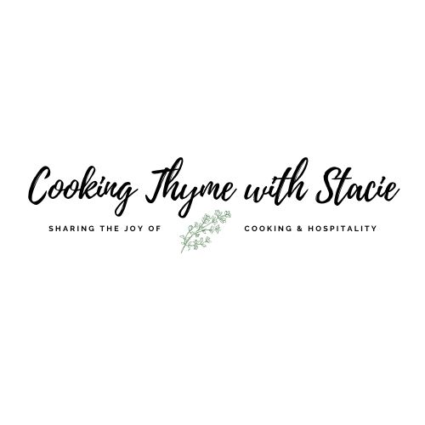

ScienceLogic
Summer Cooking Class

Wednesday, July 15, 2026
11 – 12 EST

Menu – Serves 6

Herb Encrusted Salmon Niçoise Salad
Homemade Vinaigrette
Roasted Potatoes

Zoom Link
https://us02web.zoom.us/j/87029161495

www.cookingthymewithstacie.com

Shopping List

Ingredient list is for preparing 6 portions – adjust as needed for fewer portions

Dairy
- 6 eggs

Pantry
- ½ cup balsamic vinegar
- 2 TB plus 6 TSP Dijon mustard
- 2 TB dark brown sugar
- 1 ½ cups olive oil
- ½ cup slice Kalamata olives
- 3 TB capers

Produce
- 2 TB minced red onion
- 4 TB fresh basil
- 12 – 14 small Yukon gold potatoes
- 6 cloves of garlic
- 1 TB fresh rosemary, chopped fine
- 1 TB Italian parsley, chopped fine
- 1 TB fresh thyme
- 6 ounces fresh green beans, trimmed
- 3 green onions, chopped fine
- 3 TB Italian parsley
- 2 TSP fresh thyme
- 2 TSP fresh oregano
- 16 ounces baby salad greens
- 12 ounces grape tomatoes

Protein
- 6, four-ounce salmon fillets

Spices
- Salt
- Black pepper

Equipment
Baking
- Rimmed baking sheet

Electric
- Food processor

Pots and Pans
- 2 Medium size pots

Utensils
- Chef’s knife
- Mixing bowl
- Measuring cups and spoons
- Parchment paper

Mis en Place
The French culinary term for “everything in its place”
In order to have a smooth cooking experience, I recommend that you retrieve all the equipment you will need for the class before we begin. In addition, if you have time, group your ingredients by recipe. Most chefs place their components on sheet pans – this is ideal if you have the room.
- Pull out all ingredients
- Organize ingredients by recipe
- Thaw fish if using frozen
- Clean and scrub potatoes

Niçoise Salmon Salad with Roasted Potatoes and Green Beans

Serves 6

Balsamic Vinaigrette

½ cup balsamic vinegar
2 TB minced red onion
2 TB Dijon mustard
2 TB dark brown sugar
½ TSP kosher salt
¼ TSP black pepper
1 cup olive oil
1 TB fresh basil, chopped

In a food processor, combine the first 6 ingredients and pulse until well combined. With the motor running, gradually pour in the olive oil. Last, add the fresh basil and pulse 2 – 3 times until mixed.

This recipe will be more than you need. You can refrigerate the extra dressing for 3 days, just shake well before using.

Mini Roasted Gold Potatoes

12 – 14 small Yukon gold potatoes, halved or quartered depending on their size
4 cloves of garlic, chopped
¼ TSP kosher salt
4 TB olive oil
1 TB fresh rosemary, chopped fine
1 TB Italian parsley, chopped fine
1 TB fresh thyme, chopped fine
¼ TSP black pepper

Preheat the oven to 400˚.

Place one rack in the top third of the oven. In a food processor, combine the garlic cloves and the salt. Pulse until it becomes a paste. Add the rest of the ingredients, pulse until well mixed.

Place all the ingredients in a large bowl and toss the potatoes until they are well coated.
Place the potatoes on a rimmed baking sheet in a single layer. Roast about 10 minutes then using a metal spatula, turn them over. Continue roasting an additional 10 – 15 minutes until they are quite browned and crispy. Remove from oven and set aside.

Green Beans

6 ounces fresh green beans, trimmed

Bring a medium size pot of salted water to a boil. Add the green beans and cook until crisp tender, about 3 minutes. Plunge them into an ice bath to stop the cooking. Drain and dry them with a paper towel. Set aside.

Eggs

6 eggs

Place the eggs in a medium saucepan covering the eggs with cold water. Place on the stove and bring the water to a boil over high heat. Once the water boils, turn off the heat and cover the pan with a tight-fitting lid. Let rest 12 minutes. Drain the hot water and replace with cool water. Peel the eggs and cut into quarters.

Herbed Salmon

6, four-ounce salmon fillets, pin bones and skin removed
3 green onions, chopped fine
3 TB Italian parsley, chopped fine
3 TB fresh basil, chopped fine
2 TSP fresh thyme, chopped
2 TSP fresh oregano, chopped
¼ cup olive oil
2 garlic cloves, minced
1 TSP kosher salt
½ TSP black pepper
6 TSP Dijon mustard

Preheat the oven to 450˚.

Line a rimmed baking sheet with parchment paper. Season the salmon with salt and pepper. Place the fillets on the baking sheet. Smear 1 TSP of mustard on top of each fillet.

In a small bowl, combine the green onions, parsley, basil, thyme, oregano, and garlic. Pour in the olive oil and stir to combine. Spread equal amounts of the herb mixture on top of the mustard coated salmon.

Bake about 7 minutes or until a thermometer reads 145˚F.

Salad Assembly

16 ounces Baby salad greens
12 ounces grape tomatoes, halved
½ cup slice Kalamata olives
3 TB capers, rinsed and drained
Quartered eggs
Roasted salmon fillets
Roasted Potatoes
Green Beans

Place the salad greens, tomatoes, olives, green beans and capers in a large bowl. Toss with some of the vinaigrette. Place salad greens equally on 6 plates. Top with warm salmon and egg quarters.

