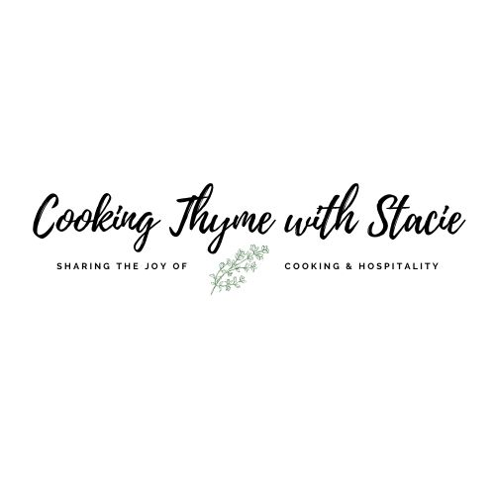

TJ’s for 2 Fish Night

Menu
Pecan and Bourbon Glazed Salmon
Whole Wheat Couscous with Pecans and Mixed Fruit
Honey Glazed Baby Carrots
Cookie Butter Ice Cream Balls with Salted Caramel

To access the class video, copy and paste the following link into your browser:
www.cookingthymewithstacie.com/ /video-class-purchase/tj2fish

www.cookingthymewithstacie.com

Shopping List

Dairy/Freezer
- 5 TB unsalted butter
- 1 container Trader Joe’s cookie butter ice cream

Pantry
- 1 TB Dijon mustard
- 4 TB honey
- ½ cup plus 2 TB Trader Joe’s chopped pecan pieces
- ¼ cup Panko crumbs
- 3 TB olive oil
- Cooking spray
- 1 cup Trader Joe’s whole wheat couscous
- 1 cup vegetable broth
- 1 bag Trader Joe’s Golden Berry Blend (dried fruit in the same section as the nuts)

Produce
- 1 bag baby carrots

Protein
- About 1 lb. salmon (I usually buy a whole piece from Trader Joe’s, not the cut ones)

Spices
- Salt and pepper
- 1/8 TSP cayenne pepper

Specialty
- 3 TB bourbon (buy 1 small “airplane” bottle from the liquor store)
- 1 jar Trader Joe’s fleur de sel caramel sauce
- 1 package Trader Joe’s cinnamon graham crackers (above the frozen foods normally)

Equipment List

Baking
- Rimmed baking sheet
- Aluminum foil

Pots and Pans
- Small saucepan
- Medium saucepan with tight-fitting lid
- Non-stick skillet

Utensils
- Chef’s knife
- Cutting Board
- Ice cream scoop
- Measuring cups and spoons
- Mixing bowl
- Rolling pin and Ziploc bag
- Spatula
- Whisk

Mis en Place
The French culinary term for “everything in its place”
In order to have a smooth cooking experience, I recommend that you retrieve all the equipment you will need for the class before we begin. In addition, if you have time, group your ingredients by recipe. Most chefs place their components on sheet pans – this is ideal if you have the room.
- Bring salmon out and check for pin bones

Pecan and Bourbon Glazed Salmon

Serves 2

About 1 lb. salmon
Salt and pepper
2 TB unsalted butter
1/8 TSP cayenne pepper
1 TB Dijon mustard
3 TB bourbon
2 TB honey
¼ cup chopped pecans
¼ cup Panko crumbs
Olive oil
Cooking spray

Preheat oven to 350˚.

Cover a rimmed baking sheet in aluminum foil. Spray with cooking spray.

Remove the salmon from the frig and bring it up to room temperature. Check for pin bones.

In a small saucepan, melt the 2 TB of butter. Add the bourbon, whisk in the mustard, honey and cayenne and bring to a boil. Lower the heat but allow the mixture to continue to cook another 2 – 3 minutes. Remove from heat and set aside to cool slightly.

In a small bowl combine the pecans and panko crumbs.

Place the salmon skin side down on the prepared baking sheet. Generously season with salt and pepper.

Pour the bourbon glaze over the surface of the salmon. Cover the salmon with the pecan/panko mixture, pressing lightly so that it adheres. Drizzle the top with some olive oil (~ 1 TB)

Place in oven and bake until the salmon is 135 – 140˚. (If you bake the salmon as a whole 1 lb. piece, it will table about 16 minutes. If you have individual pieces of salmon, adjust the cooking time down!)

Remove from the oven. Slide a spatula between the fish and the skin to remove the skin for serving.

Whole Wheat Couscous with Pecans and Mixed Dried Fruit

1 cup Trader Joe’s whole wheat couscous
1 cup vegetable broth
2 TB butter
½ cup Trader Joe’s pecan pieces
¼ cup Trader Joe’s Golden Berry Blend
2 TB olive oil
Salt to taste.

In a medium saucepan, bring the broth and 2 TB butter to a boil. Pour in the couscous and stir. Cover with a tight-fitting lid and remove from the heat. Allow to steam 5 minutes. Fluff with a fork and stir in the pecans, dried fruit and 2 TB of olive oil. Salt to taste.

Serve immediately.

Honey Glazed Carrots

Serves 2 (easily doubled)

1 ½ cups baby carrots
2 TB water
1 TB unsalted butter
2 TB honey

Place the carrots and water in a microwave safe bowl. Cover with plastic wrap.

Microwave 2 ½ minutes. Drain the water.

In a medium, non-stick skillet melt the butter over medium-low heat. Add the carrots and honey. Stir frequently and cook until desired doneness, about 4 – 6 minutes.

Cookie Butter Ice Cream Balls with Caramel

1 container Trader Joe’s cookie butter ice cream
1 package Trader Joe’s cinnamon graham crackers
2 TB Trader Joe’s pecan pieces
1 jar Trader Joe’s fleur de sel caramel sauce

Place 4 graham crackers in a Ziploc bag and crush until the size of bread crumbs with a rolling pin (or blitz in a food processor). Mix in the pecan pieces.

Roll one scoop of ice cream in the graham cracker and pecan mixture. Repeat with second serving.

Drizzle with caramel sauce and serve.

